Hormuz Strait Closure — Beneficiaries — AlphaSense Prompt B
Prompt B Output | 18 March 2026
The effective closure of the Strait of Hormuz on 4 March 2026 has fundamentally altered global energy and logistics dynamics, creating a distinct class of tactical beneficiaries over the next 6–24 months. While the disruption has caused Brent crude to spike as high as $120/bbl and halted 70-80% of regional vessel traffic, the most durable investment opportunities are emerging in non-Gulf energy production, high-specification maritime shipping, and European petrochemicals. Below is a detailed analysis of the beneficiaries, management sentiment, and the specific regulatory shifts—including a surprise 60-day Jones Act waiver—that are defining the 2026 investment landscape.
17 Mar
•
Prepared By Economic and Financial Market Analysis Team 2026
Chart showing the dramatic drop in tanker traffic through the Strait of Hormuz in March 2026
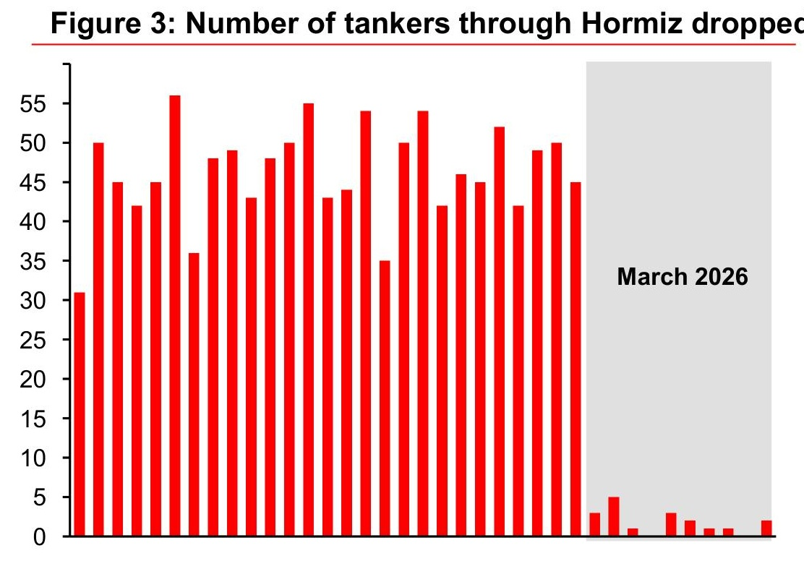
Fundamental Validity: Top Beneficiary Sectors
Maritime Shipping and Logistics
The shipping sector is the most immediate beneficiary of the Hormuz closure as freight rates have repriced "overnight" due to the near-halt of transport in the Strait.
- Pricing Power: Global freight markets have seen a massive windfall, with elevated rates being "locked in" by carriers regardless of the conflict's duration. War-risk insurance premiums have surged, and major container carriers like Maersk, MSC, and Hapag-Lloyd have implemented emergency freight increases and booking stops for Gulf-destined cargo.
- Volume and Margin: Volumes are being rerouted around the Cape of Good Hope, adding 10–14 days to Asia-Europe and Asia-U.S. East Coast voyages, which effectively tightens global vessel capacity and supports higher margins.
- Management Sentiment: Teekay Corp management noted that while they haven't seen a total closure historically, current consolidation in the VLCC (Very Large Crude Carrier) segment creates a different dynamic where charterers must move quickly to secure tonnage, driving up rates.
Non-Gulf Energy Production
Energy producers outside the Persian Gulf are seeing significant fundamental improvements as they fill the supply gap of approximately 14 million barrels per day locked behind the chokepoint.
- Production Guidance: Vår Energi has confirmed a 25% to 30% increase in Capex to support production goals, reflecting confidence in the long-term pricing environment.
- Pricing Benchmarks: Brent crude reached $120/bbl shortly after the closure, and even as it fluctuated between $88 and $100, the geopolitical risk premium remains a structural tailwind for non-OPEC producers.
- Dividends and Capex: Repsol announced it will distribute 30% to 40% of cash flow from operations through dividends and buybacks, with dividend per share expected to grow 6% to 9% annually.
European Petrochemicals
European chemical producers are emerging as "accidental" beneficiaries due to the cessation of imports from the Middle East and China.
- Local Market Advantage: LyondellBasell (LYB) management highlighted that for local producers in Europe, the reduction in supply from Middle Eastern competitors who are "trapped" behind Hormuz creates a positive event.
- Margin Expansion: If local producers can adjust prices to match raw material costs, they are in a "pretty good place" with the ability to increase prices as supply is reduced. Approximately 30% of global Polyethylene (PE) capacity is affected, with half of that trapped in the Middle East.
Broker and Analyst Activity
Broker research has concentrated on identifying companies with the highest leverage to spot rate spikes and those capable of sustaining production amid global volatility.
- Upgrades and Focus: Research is heavily focused on the tanker segment, specifically companies like Frontline (FRO), Scorpio Tankers (STNG), and International Seaways (INSW), where analyst activity is tracking the surge in spot rates.
- Energy Sector Sentiment: Analysts are monitoring Vår Energi (VAR.NO) and Repsol (REP.ES) for their disciplined Capex plans and ability to deliver material improvements in per-share value metrics.
- Diverging Views: Disagreement among analysts primarily concerns the duration of the closure. While some see a "low-probability tail risk" for prolonged closure, others warn that even after hostilities ease, it will take months for supply chains to normalize.
Sector | High-Conviction Names | Primary Analyst Focus
Tanker Shipping | Frontline (FRO), Scorpio Tankers (STNG) | Spot rate leverage and VLCC consolidation dynamics.
Energy (Exploration) | Vår Energi (VAR.NO), Repsol (REP.ES) | Capex increases and shareholder distribution growth.
Logistics/Air Freight | Deutsche Lufthansa (LHA.DE) | Shift from sea freight to air freight for time-critical goods.
Source:
Key Players and Competitive Dynamics
The competitive landscape is being reshaped by those who control "un-trapped" assets and those with the flexibility to pivot operations.
- Shipping: International Seaways and Teekay are positioned to benefit from the fact that 20 million barrels a day through Hormuz is "not a sustainable situation" to lose, forcing charterers to pay premiums for any available tonnage outside the Gulf.
- LNG Specialists: New Fortress Energy (NFE) is focused on fully utilizing its 4 MTPA of gas supply with matched downstream portfolios in Puerto Rico and Mexico to insulate itself from global supply volatility.
- Manufacturing: Fuel Tech (FTEK) is seeing a 37.20% revenue increase in its FUEL CHEM segment as coal-fired units in the U.S. are run at "maximum utilization" to keep up with energy demand spikes.
"On the regulatory front, the recent U.S. Environmental Protection Agency's (EPA's) actions that repeal the 2009 endangerment finding and repeal the 2024 Mercury and Air Toxics Standards for coal fired units could actually benefit Fuel Tech as some of the coal plants that were either closed or scheduled to close could continue to run and require NO x limiting equipment from the company."
HC Wainwright • 5 Mar
• Amit Dayal • "Sales Pipeline Remains Healthy in an Evolving Regulatory Environment; 4Q25 Results Update"
Regulatory and Policy Tailwinds
Governments have taken unprecedented steps to stabilize markets, creating new winners and losers.
- The 60-Day Jones Act Waiver: On 18 March 2026, the Trump administration announced a temporary 60-day waiver of the Jones Act to allow foreign ships to carry fuel and agricultural goods between U.S. ports. This is intended to combat "soaring fuel prices" and ensure resources like oil, natural gas, and fertilizer flow freely.
- Strategic Reserve Releases: The International Energy Agency (IEA) announced the largest coordinated release of strategic reserves in history, with 400 million barrels to be made available over four months; the U.S. will contribute 172 million barrels.
- U.S. Navy Escorts: U.S. Energy Secretary Chris Wright indicated the Navy could begin escorting commercial vessels through the Strait by the end of March if conditions require.
Bear Cases and Strategic Risks
Maritime Sector Bear Case: "Demand Destruction"
- The Risk: A prolonged shutdown could lead to the "total destruction" of tanker demand if the volume of oil available to be shipped falls more sharply than the increase in ton-miles from rerouting.
- Jones Act Impact: For domestic operators like Matson (MATX) and Kirby Corp (KEX), the 60-day waiver is a major negative. Matson has warned that any waiver of the Jones Act would allow competitors with lower operating costs to enter their core markets, adversely affecting their business. Kirby similarly flags that foreign-flagged vessels are not subject to the same U.S. regulations and tax laws, creating an unlevel playing field.
Energy Sector Bear Case: "Inventory Overhang"
- The Risk: If the conflict is short-lived, the massive release of strategic reserves (400 million barrels) could lead to a significant oversupply by Q3 2026, causing spot prices to crash back to the mid-$60s.
- Operational Bottlenecks: Companies like LyondellBasell warn that even if the Strait reopens, assets on the "east side" of the Strait will run out of storage quickly, and it will take months for the entire supply chain to "normalize."
Thin or Conflicting Evidence
- Institutional Ownership: Current 13F data reflecting institutional shifts specifically since the 4 March closure is not yet fully available in primary filings.
- M&A Activity: While there is speculation regarding consolidation, no major M&A transactions have been confirmed for Frontline or Scorpio Tankers specifically in the 14 days following the closure.

